Predictive Analysis of Stock Price Using Random Forest Algorithm

Prepared By
Mahesh Suravajjala
ID: 0003646255
for
[FA15-BL-INFO-I590-34717]
Big Data Applications and Analytics

GIT: https://github.com/maheshs009/Project

Summary
Primary purpose of this project is to train a Random Forest model to predict bank stock prices. Historical information of various market factors or features are used to train the Random Forest model. This project highlights the most important macroeconomic factors or features that would potential drive any stock price. A total of 25 different features/factors are considered, and last 10 years’ data has been used to train and test the Random Forest model.
Most of the data used is real market data (both training and results), in order to avoid any conflicts, we will refer to the Bank that we are predicting stock price of as Bank A.
Key Highlights:
Random Forest Algorithm implemented and optimized using Python
Total number of features included: 25
Total number of data points: 2751 (01 Jan, 2005 to 03 Dec, 2015)
Model score (R^2) : 0.88 – Predicted stock price values are 88% correlated to actual stock prices.

How to run
GIT: https://github.com/maheshs009/Project
Toolkit used: sklearn on the VM
Dataset:
Python Code:
Future Systems:
Login: msuravaj
All data is available on the VM machine - /home/ubuntu/Project/Data
IPython Files are available here - /home/ubuntu/IPythonFiles
Two files:
- RandomForest_Optimizer.ipynb (contains steps to optimize the model)
- RandomForest.ipynb

Introduction
Machine learning and other predictive analytics will start playing an increasing role in the financial world. While technical analysis (method of studying markets to predict future prices), and algorithmic trading have been around for a while, there are lot of other areas of finance where predictive analytics could play a major role. Collateral movements are one of the post-trade functions where billions of dollars are moved around on a daily basis. Collateral movements are purely based on daily market movements, and financial firms will need to make sure that they maintain enough liquidity to meet these collateral calls on a daily basis. Collateral is posted to the counterparties as a security based on the market movement. In order to post collateral, firms will need to maintain liquid cash/treasuries on a daily basis, which could otherwise be used for trading. Predicting collateral requirements is a key to financial firms to maintain a tight liquidity so that neither too high nor too low is maintained on a daily basis. While there is no straight forward of calculating the collateral needs of the firm directly, however, credit rating of the firm plays a key role. Credit Ratings have a huge impact on the stock price of a firm, so various fundamental market factors are considered to predict the stock price, which in turn, should help to predict collateral movements.
Identifying the parameters that impact the price movement of a financial firm is one of the primary outputs of this exercise. As a part of this project, Python based random forest algorithm that can predict the market movements of a financial firm (like Goldman Sachs or JP Morgan or Morgan Stanley) has been developed. Last 10 years’ data has been availed to implement a supervised learning technique that can predict simple price movements and thereby other financial aspects of the firm. In a way, this could also help see if Random Forest techniques are applicable to financial data, or if overfitting might turn out to be a problem.

Random Forest Introduction
Random forest algorithm, as defined in wiki, is an ensemble learning method for classification, regression that operate by constructing a multitude of decision trees at training time and outputting the class that is the mode or median of the classes. Random Forest is both a classification and regression algorithm developed by Leo Breiman and Adele Cutler. This technique uses a number of decision tree models to predict precisely by reducing the bias and variance of the estimates. This model is an ensemble since it aggregates many models together to produce a single final prediction. Algorithm of this model, on high level, is:
- Create large number of decisions trees based on different subsets of variables
- Bootstrap observations for each tree
- Randomly select and use only part of the variables for each tree
- Estimate the performance for each tree using the samples excluded
- An average for regression estimates is derived as final prediction

Data Sources
General market indicators have been selected to act as the features/variables to train this model. Variables selected are:
- S&P 500 – daily low, high, close prices
- VIX – Volatility Index. This indicates how much volatile the markets are. – daily low, high, close prices
- Banking Index – Index of all banking stocks – daily low, high, close prices
- LIBOR Rates – 1-week, 1-month, 3-month, 6-month, 12-month rates
- OIS – Overnight Interbank Spreads
- Day of the week
- Month
- Historical stock price of a bank (referred to as Bank A)
Data has been sourced from multiple platforms. LIBOR rates have been sourced from St. Louis Fed research website (here). S&P, Bank A stock price are retrieved from Yahoo finance, and VIX has been retrieved from Quandl.com
All the data has been sourced from 01/03/2005 to 12/03/2015.

Data Curation – Data Loading/Cleaning
Data Loading:
There are total of 25 features loaded for the period of 10 years – Jan 1 2005 – till date. Please note that features and variables are interchangeable used all through this documentation. Features are usually divided into Dimensions (Categorical) and Measures (Numerical).
Training data, and results are loaded using pandas csv read module as shown below.
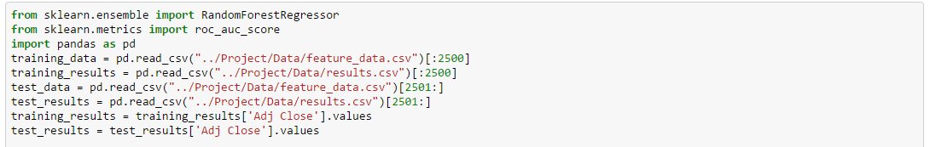
Total number of rows in the data set is 2751. This dataset is further broken down into training_data and training_results, & test_data and test_results data sets. Training datasets will be used to train the model ([:2500] – first 2500 rows) and next 251 rows will be used to test the model ([2501:]).
And the last two lines in the above screenshot are needed to convert the result set from vector to 1-D array to avoid below warning:
-c:3: DataConversionWarning: A column-vector y was passed when a 1d array was expected. Please change the shape of y to (n_samples,), for example using ravel().

Numerical Data Curation:
Now that the data is loaded, we now check if all the data fields are populated. Check for any blanks, by running the describe () on training_data set.
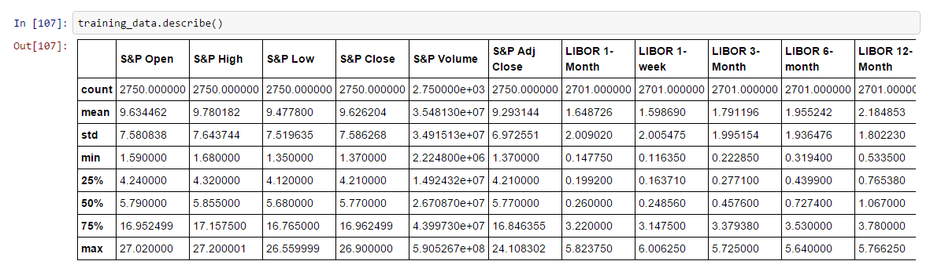
As you could see above, there are a total of 2750 values in each column. However, there a few missing values in LIBOR rates as shown above (total 2701 values present). In Random forest, we usually replace the missing values with the median of the feature. In Random Forest, decision trees are split on a certain value, and if it is less than a value it goes left and if greater than a value if goes right. So, if a median is picked in place of a missing value, it is not going be biased one way or the other with respect to that feature.
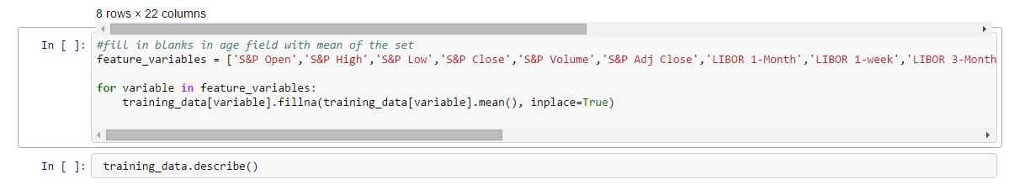
As you could see below, all the missing values are replaced with mean so the total count across all the features is 2750.
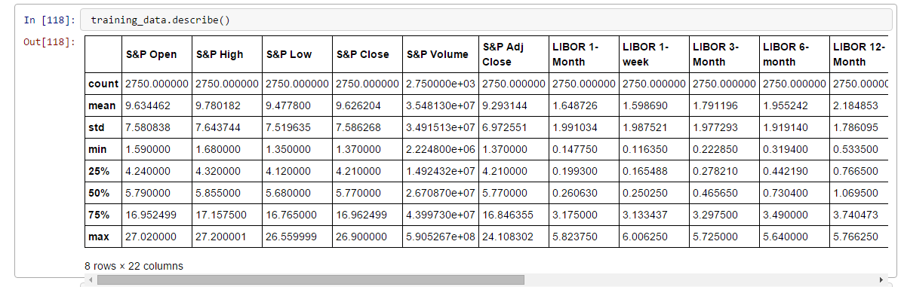
We need to make sure both the training_data and training_results have the same number of entries.
Categorical Data Curation:
As discussed above, every data set has two types of variables, dimensions (categorical) and measures (numeric). While numeric can be used directly for decision trees, categorical values will need to be dealt with carefully. In this dataset, there are 3 categorical variables as shown below:
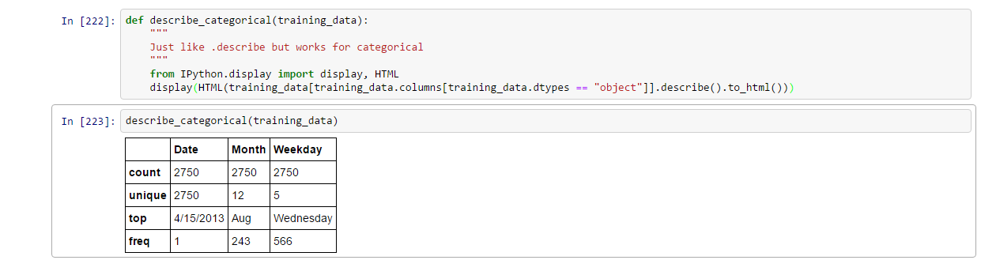
While Weekday might have an impact on the way stock price of a bank can move, the actual date might have little or no impact at all. Technical analysis of stocks does highlight the fact that stock price is impacted by Quarterly results, so month of the year might have some impact. So, Weekday, and Month will be left, while Date will be dropped.
So, we will convert these categorical values – Month and Weekday into Boolean values. This way, these features can be used in decision trees. Dummies module in pandas support creation of dummy features in place of existing features. So, we create dummy variables using WeekDay – {Monday to Friday} & Month – {Jan to Dec} respectively.
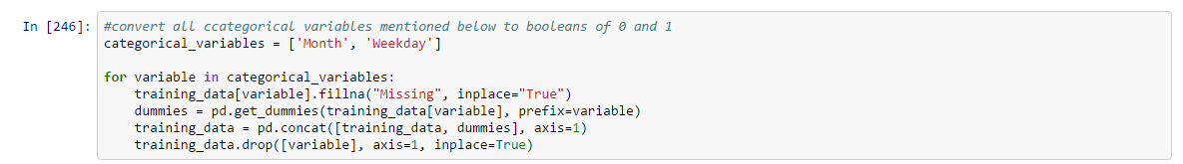
To confirm, we printall the features one more time:

Month:
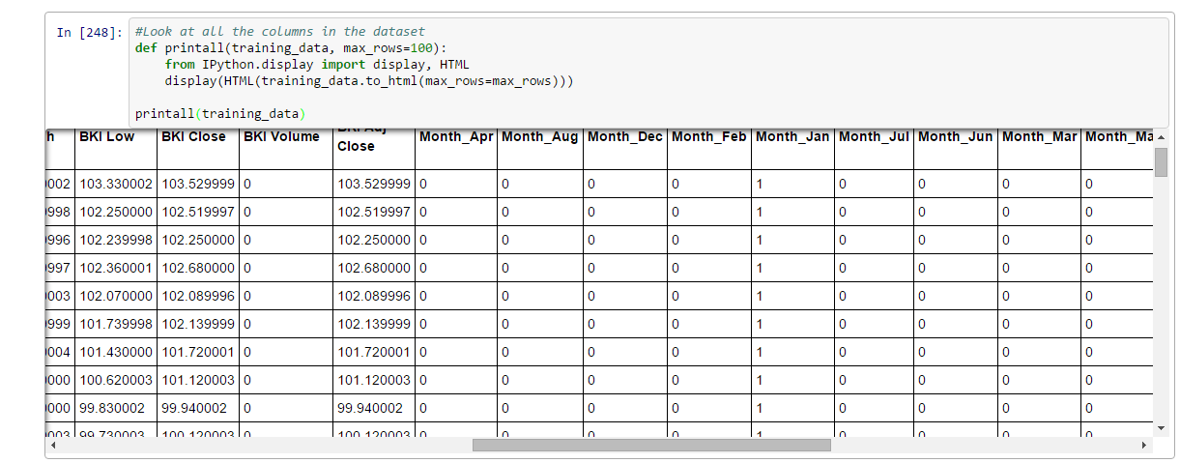
Weekday:
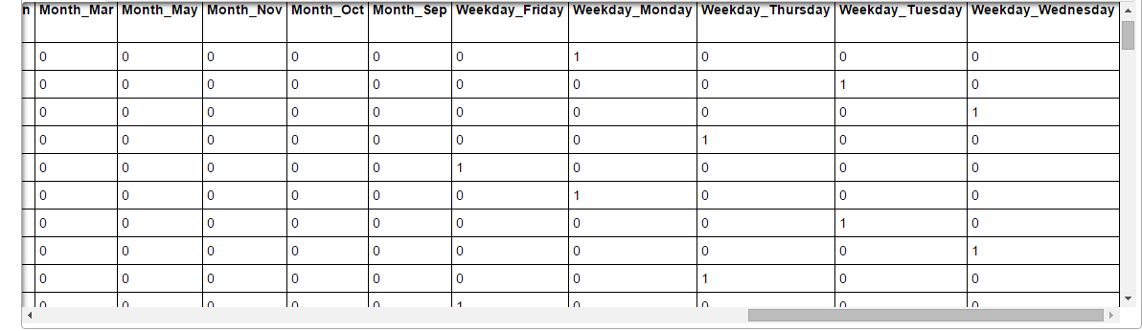
To confirm the dimensions

random forest – feature importance & correlation
Features & Importance:
Now that the data is curated, and organized, Random Forest model can be run to understand the feature importance. Running the model with default settings
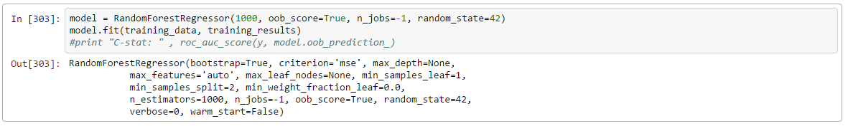
Model.feature_importance_ explains the importance of all the features in the training data set as shown below.
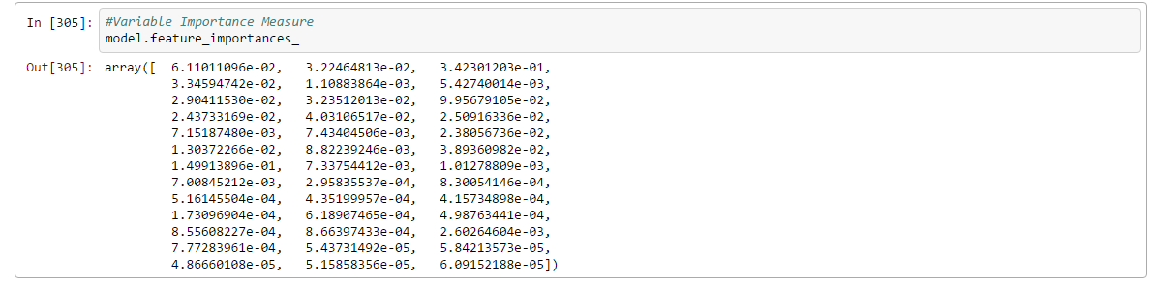
To represent the same in graphical format:
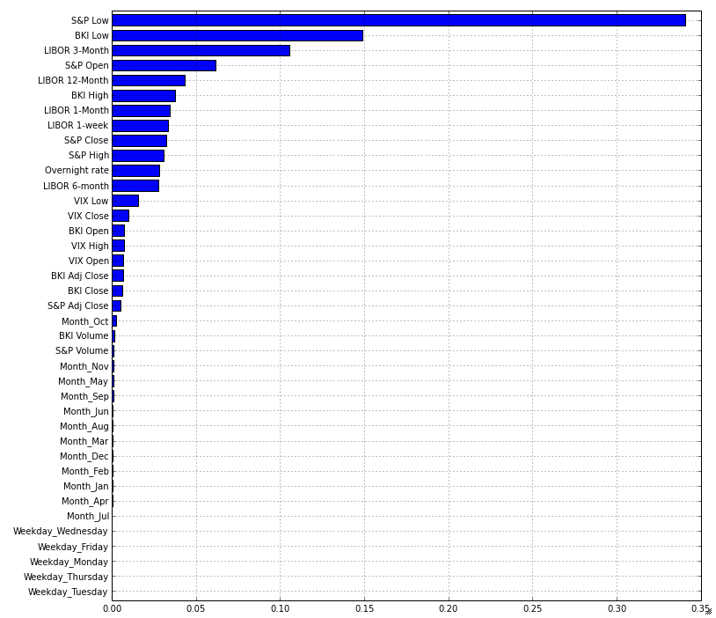
As defined by the graph, S&P Low, Banking Index Low, LIBOR 3-month rate, S&P Open, and LIBOR 12-month are some off the most important features that are informative, while the rest are not.
If traditional analytics were to be used, below is how correlation between the two 2 features (S&P and BKI) highlighted by above graph will stand:
R2 = 0.0066 (Between Stock Price and S&P Low)
Stock Price = 0.364092*S&P Low + 138.68
R2 = 0.13339 (Between Stock Price and BKI)
Stock Price = 0.471347*BKI Low + 109.646
Developed using Tableau
Traditional correlation factor R2, with 0.006 & 0.133, does not show that stock price has a great correlation with S&P Low or BKI Low price, but Random Forest paints a different picture. This could be deemed as one of the primary advantage of using an ensemble model like Random Forest.

Number of trees (n_estimators):
n_estimator option defines the number of decision trees created. This has an impact on the accuracy of the model. A simple customized grid search algorithm can be run to find the optimal size of the decision trees needed for our model. As a part of this algorithm, RandomForestRegressor is run through different options for n_estimators like [30, 50, 100, 300, 500, 700, 1000, 1200] and out of bag (oob) and model scores are calculated.
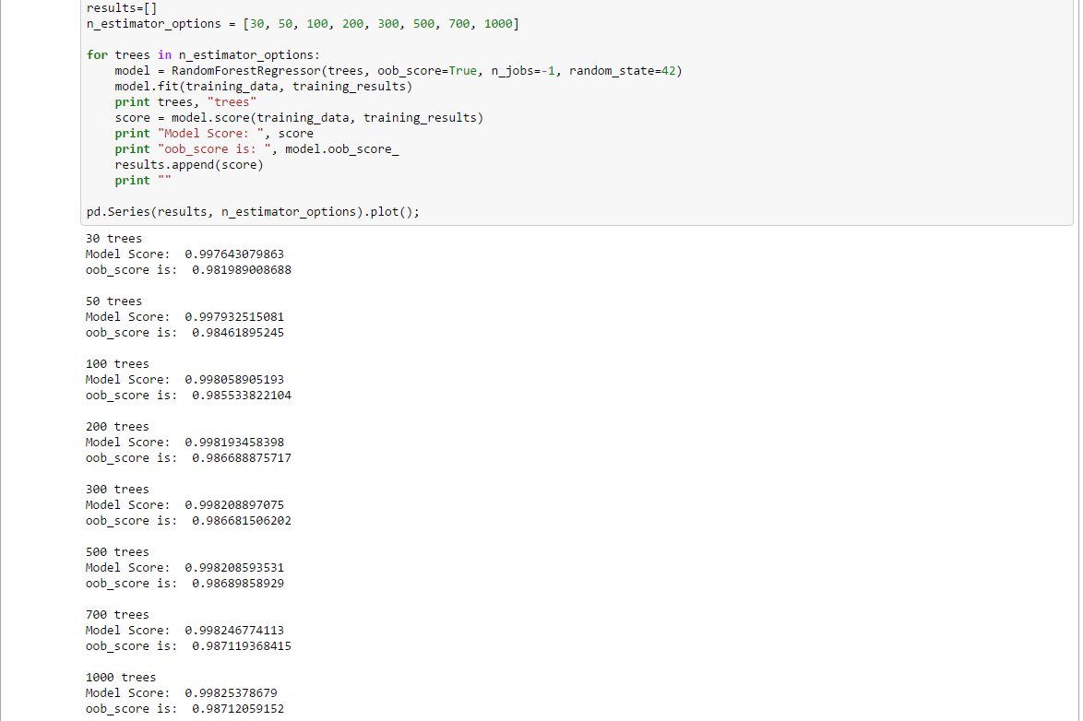
If these numbers are plotted, we can see the below. As shown in the plot, it becomes –estimators stable between 700-1000 trees, and thereafter it kind of flattens out. From this, it can be deducted that n_estimators need to be between 700-1000.
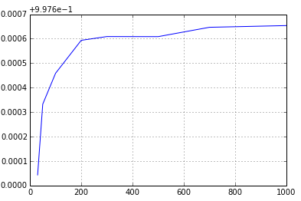
Max_features:
Max_features are the number of features Random Forest considers at each split point of the decision tree. Given that this exercise is to predict the value of a stock price (and not a Boolean), it is recommended that we use all the variables at each split point. However, a quick check could be run to understand the behavior. This algorithm will be run with max_features varying between [auto, none, sqrt, log2, 0.9, 0.2]. Default option is “auto”.
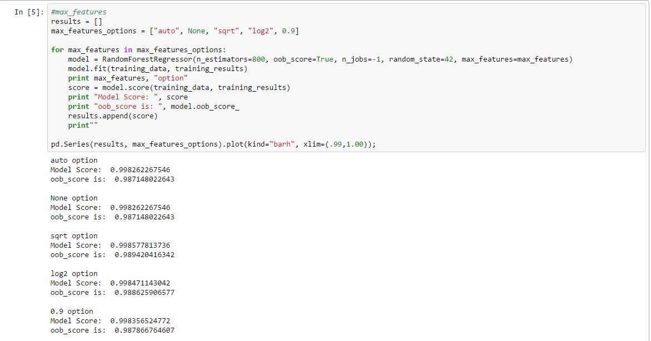

Representing these through plot shows that sqrt of total number of features will probably be enough to run this algorithm. While sqrt is usually an option used for classification problem, regression problems are usually defaulted to auto.
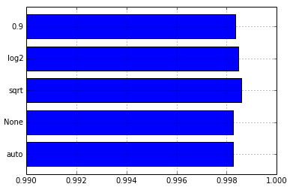
Min_sample_leaf:
This is minimum samples per leaf. Decision tree is split further and further until there is only 1 observation left. However, models can be trained to stop splitting further by defining min_sample_leaf. Here, we will use the options [1, 2, 3, 4, 5, 6, 7, 8, 9, 10] to understand the accuracy of the model.
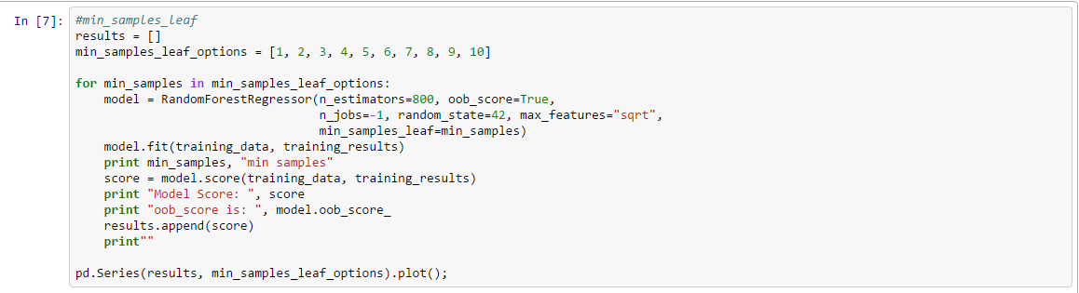

Results:
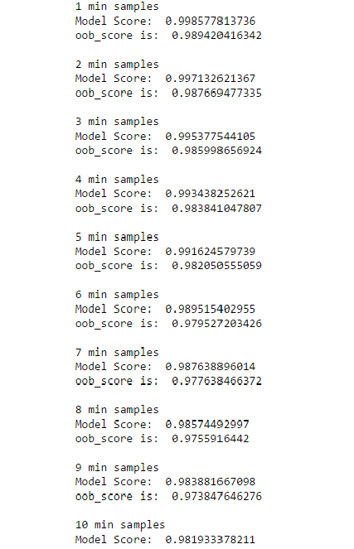

Plotting the output shows that accuracy of the model decreases as the min_sample_leaf goes down. So, the model needs to have a min_sample_leaf value of 1.
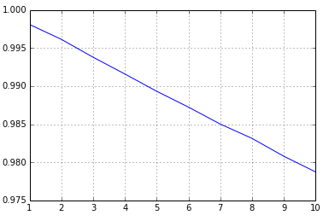

Throughput
Throughput of the model is decided by the number of cores used to run the model. N_jobs field lets you define how many cores of the existing cores on the server can be used to run this model.
A value of n_jobs=-1 means that all the available cores will be used for this model. And noted below, the best run took 2.89 sec.
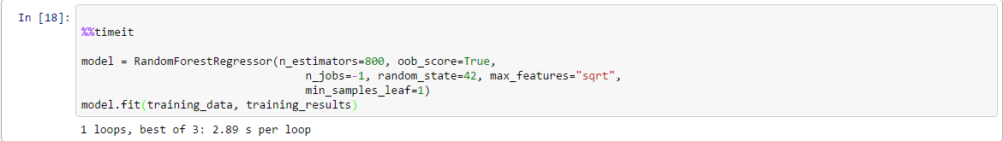
A value of n_jobs=1 means that 1 core out of the available cores will be used for running this model. As noted below, the best run took 7.05 sec
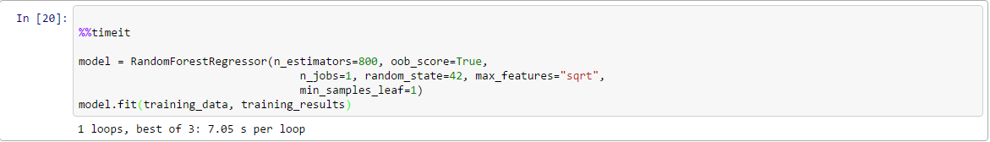
Thanks to future systems setup, I was able to increase my VM to (m1.xlarge flavor), which has 8 vcpus and 16g ram. So the model run took 2.8 sec to run on future systems. If the same model were to run on my dual core laptop it takes 4-5 sec per run.

Random Forest
Now that all the important attributes have been tested and optimized, Random forest model can be run using these optimal values.
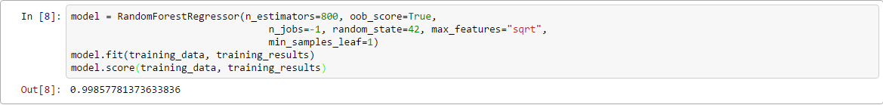
Now that the model is run, it can be tested.
Prepare Test Data:
One of the pre-requisites for running Random Forest is to have same number of features in the test data, as in the training data. And the test data will need to be prepared, as training data was done. Below code snippet does the same.
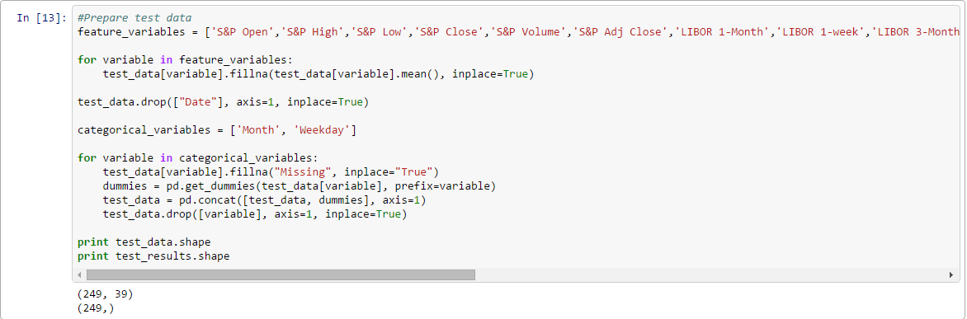
Now the test data and results can be run through the model to figure the model score.
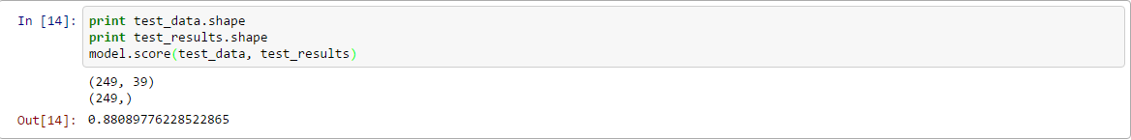
Model takes the test_data and generates the predicted stock price of the values, and then compares it with the test results (actual value) and generates a score. The score is nothing but the coefficient of determination R^2 of the prediction. R^2 of 0.88 suggests that the model predicts the values close to 88% of the actual values.
Predicted stock values can be stored in the file as shown below.

Results
A quick graph of the actual vs predicted values shows that the values are mostly correlated. Actual value of the stock price has usually been outsmarting the predicted value.
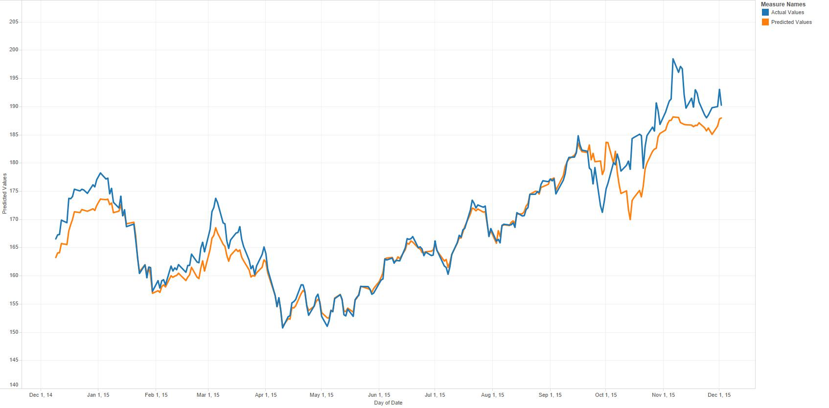
Developed using Tableau
- Actual value (blue line) is more than the predicted value (orange line). This is expected. There are a lot more features/attributes that impact the stock price of a bank.
- There is a lot more volatility in the actual value, compared to predicted value. Stock prices react to many of the qualitative and quantitative factors apart from the features included in this project.
- The model can be definitely fine-tuned further. There are other features like quarterly results, and bank fundamentals that can make the prediction a lot more robust.

Next Steps
If this model were to be turned into a complete application, below are next steps:

- Write an API to gather the feature data real time. Most of the feature/attributes used in this model are available through feeds real-time from various systems like Bloomberg, Reuters quandl etc.
- Collect the data in NoSQL server like Mongo Db. This way the features/attributes can be added/removed real-time. So a traditional relational db does not work
- More features need to be added, as the current set of features are very generic and not specific to Banking sector. Different stock prices can be predicted based on different features available. Algorithm can be fine-tuned to pick different features for different sectors.
- One of the major uplift needed for this model will be to include “Sentiment Analysis”. Stock prices are vulnerable to market sentiments, as much as they are to the attributes used for this model. For ex, actual stock price in the graph above is always higher and volatile than the predicted value because stock price reacts to different market events.
- If the model were to be made robust, “sentiment analysis” will be a major feature. This will include market events like rise in coupon payments, major firms filing for bankruptcy, change in political system or unpegging a major international currency (swiss franc was unpegged earlier this year from USD).
- Over-fitting is one of the common problems with ensembling techniques like Random Forest. Test this model for over-fitting problem.
- Use Hadoop infrastructure to collect and store the date.
- Work in a team!!! This could have been a fully functional web application if there were more hands.
Finally, a big thank you to support group. You guys have been amazing and quick on feet!!!

References
- http://scikit-learn.org/stable/modules/generated/sklearn.ensemble.RandomForestRegressor.html#sklearn.ensemble.RandomForestRegressor.score
- https://www.youtube.com/watch?v=0GrciaGYzV0
- https://www.kaggle.com/c/titanic/details/getting-started-with-random-forests
- http://www.bios.unc.edu/~dzeng/BIOS740/randomforest.pdf
- https://www.youtube.com/watch?v=MRi99ax50sw
- http://www.analyticsvidhya.com/blog/2015/09/random-forest-algorithm-multiple-challenges/

